**Homework Week 1**

**Question 1** Which of the following is true?   
The propositional statement (P & Q) → (P v Q)

1. Satisfiable but not valid
2. Valid
3. A contradiction
4. None of the above

Justify your answer.

**Question 2:** If F is a formula over *n* different letters in propositional logic, answer for each of the 4 cases a-d how many models (satisfying truth assignments) F has:  
a. if F is inconsistent   
b. if F is satisfiable   
c. if F is unsatisfiable   
d. if F is valid

**Question**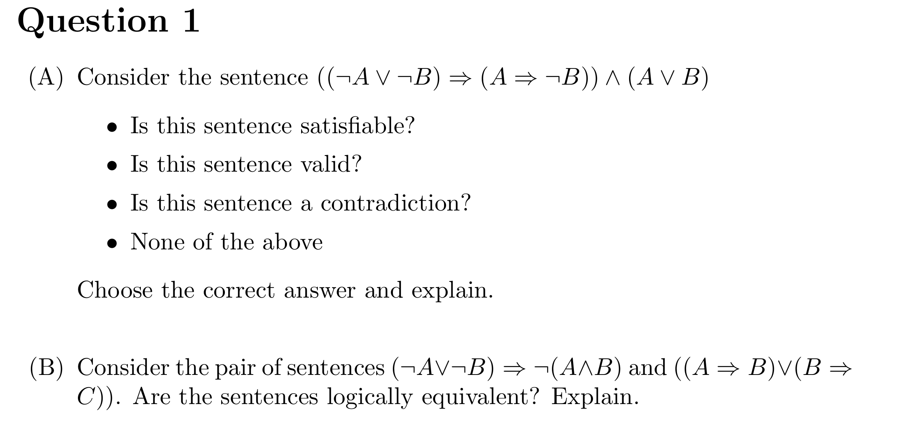、**Question 4**

Give the correct option (must, may, cannot) for each of the below

Given a sentence S and a truth assignment M for all symbols that occur in S:

1. if M is a model for S, then S {must, may, cannot} be consistent
2. if M is a model for S, then S {must, may, cannot} be a tautology
3. if M is a model for S, then S {must, may, cannot} be a satisfiable sentence

**Question 5**

* 1. How can the attempt to construct a model for a logical formula help to prove the consistency or inconsistency of that formula?
  2. How can you solve a puzzle by constructing a model for a logical formula?